NOTIFICATION TO PARENTS / GUARDIANS
BOARD OF EDUCATION
LAURA EDGHILL
President

JIM BIRKO
Vice President
LINDA CORBAT
Secretary
RON DELVILLANO
Treasurer

TODD KOCH
Trustee

DANIEL STAWINSKI
Trustee

SCOTT WALLACE
Trustee

ADMINISTRATION

DAVID RICHARDS, Ph.D.
Superintendent

CARRIE WOZNIAK
Assistant Superintendent

KERRY TERMAN
Human Resources Director
LAURIE VIDETTA, CPA
Business Manager

LYNN SOSSI
Special Education Director

DAN WATERS
Operations, Maintenance & Transportation Director

TROY LINDNER
Technology Director

KRISTIN LEDFORD
Communications Director

Fraser Public School Board of Education has established a program of instruction, which includes HIV/AIDS and other serious communicable disease prevention education and sexuality education.
According to Michigan law, you have the right to review the materials and curriculum content to be used in HIV and other serious communicable disease prevention education, as well as sex education. The local board of education, in compliance with the statute, has made the materials and curriculum guides available for your review. If you wish to review the materials or curriculum content, please contact your student’s building Principal to arrange a time for review. You also have the right to observe instruction in your child’s classroom. If you wish to do this, please call your student’s building Principal to make arrangements.
This statute allows you to excuse your child from participation in the classes that include HIV and other serious communicable disease prevention instruction, as well as sex education if you choose. If you wish to exercise your right to excuse your child from instruction without penalty, please complete the form below and return along with a written notice to the principal of your child’s school before the instruction begins.
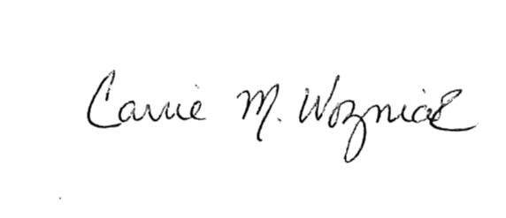
Sincerely,

Carrie Wozniak
Assistant Superintendent

Parent Request to Excuse Student from Reproductive Health and/or HIV Education

1. _______ My child will be excused from the instruction only for the lessons regarding HIV/AIDS and Reproduction.
2. _______ My child will be excused from the HIV/AIDS and reproductive instruction and all future reproductive health education instruction until I further notify the principal of my child’s school.

Student Name: _________________________________________________

______________________________________________________________
Parent Signature Date

